Ideation Phase
Define the Problem Statements

Date | 14 feb 2026
Team ID | LTVIP2026TMIDS24293
Project Name | Deep Learning Fundus Image Analysis for Early Detection of Diabetic Retinopathy
Maximum Marks | 2 Marks

Customer Problem Statement Template:
Diabetic retinopathy is a serious eye disease caused by prolonged diabetes and often remains undetected until it reaches an advanced stage, leading to irreversible vision loss. Early diagnosis is crucial for effective treatment and prevention of blindness; however, traditional screening methods are time-consuming, costly, and require specialized ophthalmologists and equipment.
This project aims to improve eye care by applying advanced deep learning techniques to predict diabetic retinopathy from retinal fundus images in a non-invasive manner. By identifying hidden patterns and abnormalities in retinal images, the system delivers accurate early-stage predictions, enabling timely medical intervention and supporting personalized, accessible, and cost-effective healthcare solutions.
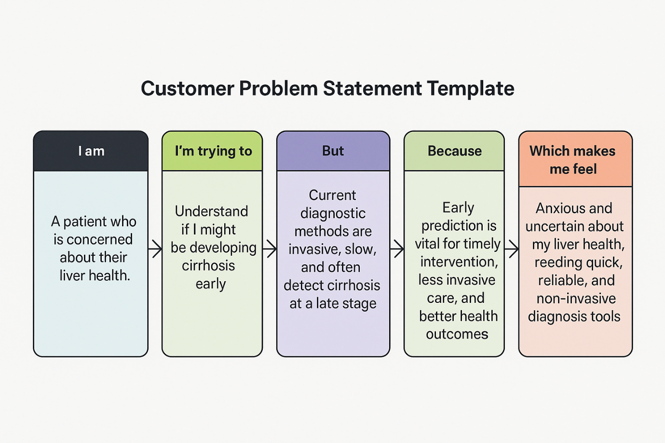

PS | I am (Customer) | I’m trying to | But | Because | Which makes me feel
PS-1 | A diabetic patient concerned about eye health | Understand if I am developing diabetic retinopathy at an early stage | Early stages show no visible symptoms and screening requires specialist examination | Early detection is critical to prevent vision loss and blindness | Anxious and uncertain about my eye health, needing a quick and reliable screening method
PS-2 | A long-term diabetic with a family history of eye disease | Know my risk of developing diabetic retinopathy early | Regular eye screenings are costly and not easily accessible | Knowing the risk early helps in lifestyle control and timely treatment | Worried and helpless due to lack of affordable and accessible eye screening
PS-3 | A healthcare provider treating diabetic patients | Detect early-stage diabetic retinopathy efficiently | Manual fundus image analysis is time-consuming and prone to human error | Automated, accurate predictions improve diagnosis and patient care | Frustrated and overburdened due to increasing patient load and delayed diagnosis
PS-4 | A diabetic patient experiencing blurred vision or eye strain | Understand whether symptoms indicate diabetic retinopathy | Symptoms are vague and confirmation requires specialist evaluation | A data-driven image analysis system can provide fast and accurate insights | Anxious and confused, needing clarity without delay or invasive procedures

